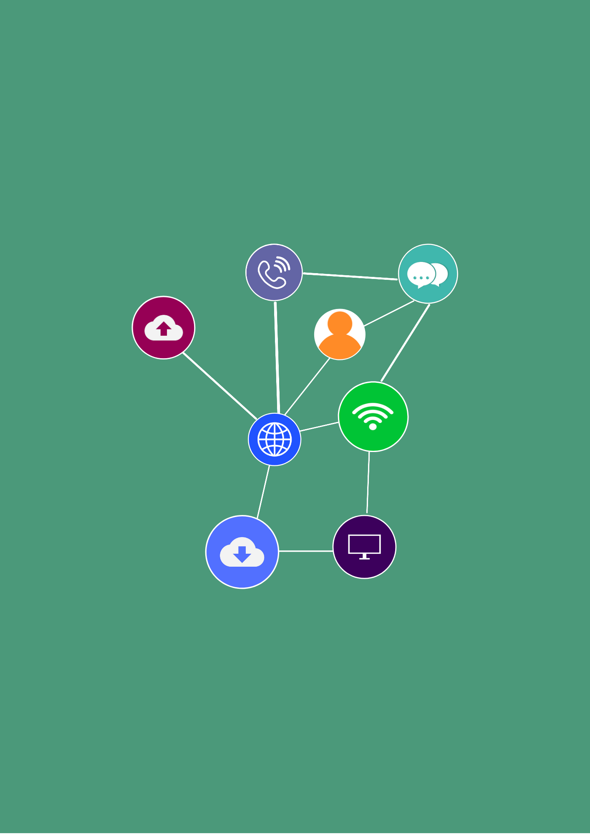

**Portfolio**

**Student Version**

**ICTWEB452**

**Create a markup language document**

First published 2021

RTO Works  
[www.rtoworks.com.au](http://www.rtoworks.com.au)

[hello@rtoworks.com.au](mailto:hello@rtoworks.com.au)

**0452 157 557**

© 2021 RTO Works

This resource is copyright. Apart from any fair dealing for the purposes of private study, research, criticism or review as permitted under the *Copyright Act* 1968, no part may be reproduced by any process without written permission as expressed in the RTO Works License Agreement.

The information contained in this resource is, to the best of the project team’s and publisher’s knowledge true and correct. Every effort has been made to ensure its accuracy, but the project team and publisher do not accept responsibility for any loss, injury or damage arising from such information.

While every effort has been made to achieve strict accuracy in this resource, the publisher would welcome notification of any errors and any suggestions for improvement. Readers are invited to write to us at [hello@rtoworks.com.au](mailto:hello@rtoworks.com.au).

IT Works is a series of training and assessment resources developed for qualifications within the Information and Communications Technology Training Package.





CONTENTS

Section 1: Prepare to develop web pages 4

Section 2: Create web pages 8

Section 3: Validate web pages 9

|  |  |
| --- | --- |
| Student name: | luke |
| Assessor: | Chuan |
| Date: |  |

You are a website designer. This assessment is to design a website showcasing your website design skills. Requirements:

* + Page 1: Home Page. Introduce yourself
  + Page 2: Design Portfolio. Pictures gallery can be added here to list sample design. You may copy sample designs from internet. Capture screenshots of these designs and save as picture (image) files. At least 10 designs (pictures) should be included in this page.
  + Page 3: Design Method. Storyboard or wireframe can serve as communication tool to convey design ideas. Additionally, you may draw a flow chart to illustrate your design process.

Design your website in CSS layout.

Minimum of 8 comments must be added to your CSS.

Required webpage components

• images

• graphics (picture)

• animation or video

• links.

• Footer

• Personal logo (with image and text)

• Consistent design style using external style sheet. Design CSS page layout and navigation bar.

• Picture gallery

• CSS fonts

* Table (4x4)

Section 1: Prepare to develop web pages

|  |  |
| --- | --- |
| Uses and audience  *List the uses there will be for your website (web pages). List at least 3 functions and 3 functions of your website.*  *Describe the audience for your website. List at least 3 types of audience.* | function  1 Introduce yourself  2 The design and beautification of the web page  3 Show the design details and process of the web page  The function of the website  1 Displays the pictures and text content of the web page  2 Be able to transmit the information  3 Can interact with each other  Audience  1 user  2 enterprises  3 clients |
| Markup language  *Document the markup language you will use. Explain your rationale for choosing this markup language for your webpage and audience.*  *(For instance, why choose html, do you have other choices? List 3 reasons to support your choice)* | 1 Be familiar with the tags and CSS used in html. HTML also allows the use of templates, which makes it easy to design web pages.  2 Almost all browsers (if not all) support this feature.  3 HTML is very easy to code. It is easier to edit. |
| Documentation  *List the documentation that you will need to develop the web pages. (list at least 3 documentations and their values in 50 words)*  *Make sure you refer to the simulation pack to assist with including your answer.* | (1) By using simulation packages  (2) Internet sites such as W3 School and W3C  (3) Course PPT and Student Guide  Simulation packages and course PPT and student guides Give us detailed examples and knowledge, and give us website suggestions and requirements. W3school and W3C software provide us with web code support and provide the knowledge of the website, to help us successfully build a website. |
| Document structure  *Include an outline of the structure of your web pages, as well as the web pages components you will use.*  *Use a diagrammatic structure to show the layout where possible.* | 1. List essential HTML document structure   <!DOCTYPE html>  <html>  <head>  <link rel="stylesheet" href="mystyle.css">  </head>  <body>  <h1>This is a heading</h1>  <p>This is a paragraph.</p>  </body>  </html>  (2) Draw wireframe, sitemap and briefly explain each web page  images  graphics (picture)  animation or video  links.  Footer  Personal logo (with image and text)  Consistent design style using external style sheet. Design CSS page layout and navigation bar.  Picture gallery  CSS fonts  Table (4x4)  You can switch to three different pages through the navigation bar. Use different CSS style fonts, footers, pictures, links and tables to show the site content to help users understand it easier. The page contains three parts: self-introduction, picture presentation, introduction, and flow chart. |
| Accessibility  *Explain how you will ensure that your website meets accessibility requirements* | List at least 3 features to support accessibility  1 By text and pictures instead of text to help some users who cannot read  2 Some people who do not use the mouse are able to access the site by touching the screen  3 Visit the site with some specific colors |

Section 2: Create web pages

|  |  |  |
| --- | --- | --- |
| Text editor  *Identify the text editor you will use here.* | List at least 3 choices.  Final: 1 visual studio code  2 notepad next  3 github online editor  List at least 3 reasons to choose the above editor  Advantages  Check for code errors in real-timeSupport plug-in functionIt has the function of assisting in editing  Disadvantages  The site is less stable and slower with latency  It is more difficult for beginners to master the operation mode  Some browsers cannot support it very well | |
| Using the text editor, create your web pages including applying styles  *Take screenshots of the code you generate and attach them to your Portfolio.*  *List the title of the screenshots here.* | Describe your page here  Page 1 https://lukehujunjie.github.io/ITC452/452project%20self%20introduction.html  Page 2  https://lukehujunjie.github.io/ITC452/452projict%20picture.html  Pag 3  https://lukehujunjie.github.io/ITC452/flow%20chart%20logo.html  See appendix 1 for screenshots, save your website as a zip file. Upload.  Links to Github pages  [ITC452/452projict picture.html at main · LukeHuJunjie/ITC452 (github.com)](https://github.com/LukeHuJunjie/ITC452/blob/main/452projict%20picture.html)  [ITC452/flow chart logo.html at main · LukeHuJunjie/ITC452 (github.com)](https://github.com/LukeHuJunjie/ITC452/blob/main/flow%20chart%20logo.html)  Links to Github source codes[ITC452/452project self introduction.html at main · LukeHuJunjie/ITC452 (github.com)](https://github.com/LukeHuJunjie/ITC452/blob/main/452project%20self%20introduction.html)  [ITC452/452projict picture.html at main · LukeHuJunjie/ITC452 (github.com)](https://github.com/LukeHuJunjie/ITC452/blob/main/452projict%20picture.html)  [ITC452/flow chart logo.html at main · LukeHuJunjie/ITC452 (github.com)](https://github.com/LukeHuJunjie/ITC452/blob/main/flow%20chart%20logo.html) | |
| *Paperclip* Attach: | Screenshots |  |

Section 3: Validate web pages

|  |  |  |
| --- | --- | --- |
| Browser and devices  *You are to test that your web pages work on:*   * *two different types of browsers* * *two different types of devices*   *List the two browsers you tested your web pages on and the two devices.*  *Take screenshots of your work to attach to your portfolio.*  *Note down at least one change you need to make to your web pages.* | Capture screenshots of your test results and save as appendix  Screenshot in folder  Screenshots of different devices and different browsers are in the file vault  Explain your test procedures.  See appendix for details.  This is to test web pages including mobile computers and tablets through different browsers and different devices, which can be opened and displayed more smoothly. On the computer side, files can be opened through different browsers. | |
| Specifications  *Check that you have covered all of the specifications for the web pages.*  *Provide a brief description here of how you have achieved this.*  *Click* [*here*](https://highrise.digital/blog/web-specification-guide/#:~:text=A%20website%20specification%20is%20a,stakeholders%20or%20points%20of%20contact.)[*link2*](https://wemakewebsites.com/blog/how-to-write-a-website-specification/) *for sample website specifications* | List at least 6 topics of your website design specifications. Insert actual document in the appendix.  1. Start by introducing yourself  2. Lay out your objectives  3. Pull out your key audiences  4. Now for the non-functional requirements  5. Website structure  6. The meaty part: functional specification | |
| Sign off  *Send an email to your assessor explaining how you have met requirements for this task, providing a link to your final web pages and seeking approval.* | Hi Chuan  Dear Chuan  This is Luke, I have completed this 452 assessment and met requirement I have completed the requirements for the project evaluation, you can visit the website I made through my link, and view the content of my webpage. You can see profiles, images, tables and page numbers, and you can switch page numbers through the navigation bar. The first page is the self-introduction, the second page is the picture show the third page of the content is my design idea. Please check.  - | |
| *Paperclip* Attach: | Screenshots |  |

Appendix 1

Computer edge Browser

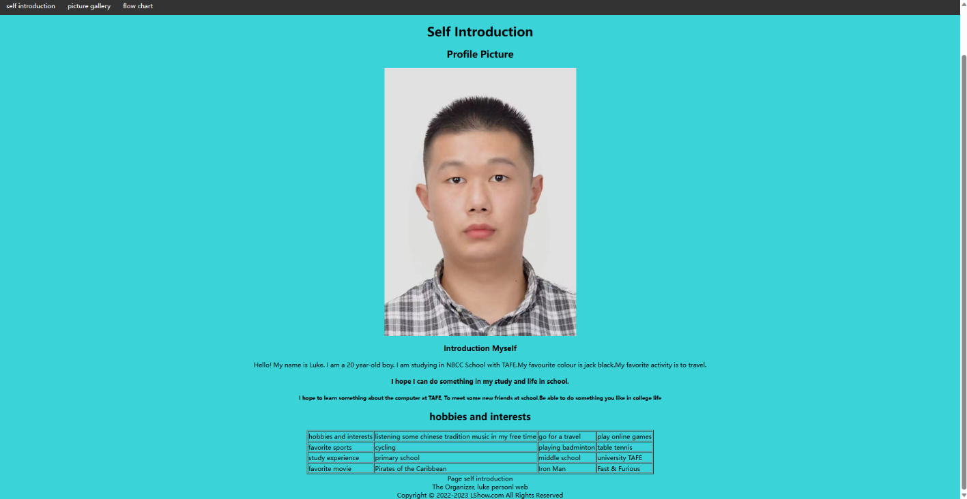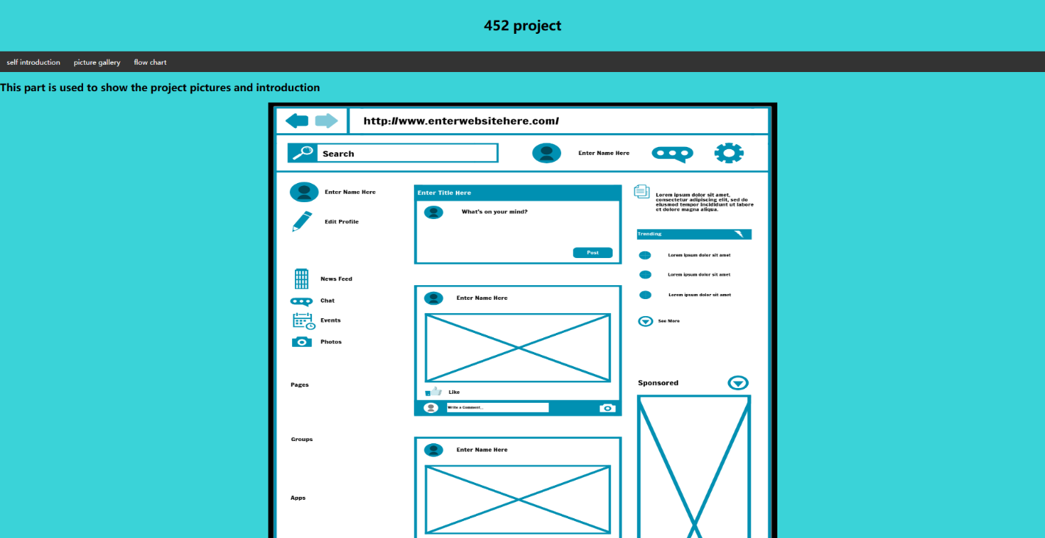

Appendix 2

iPad safari Browser

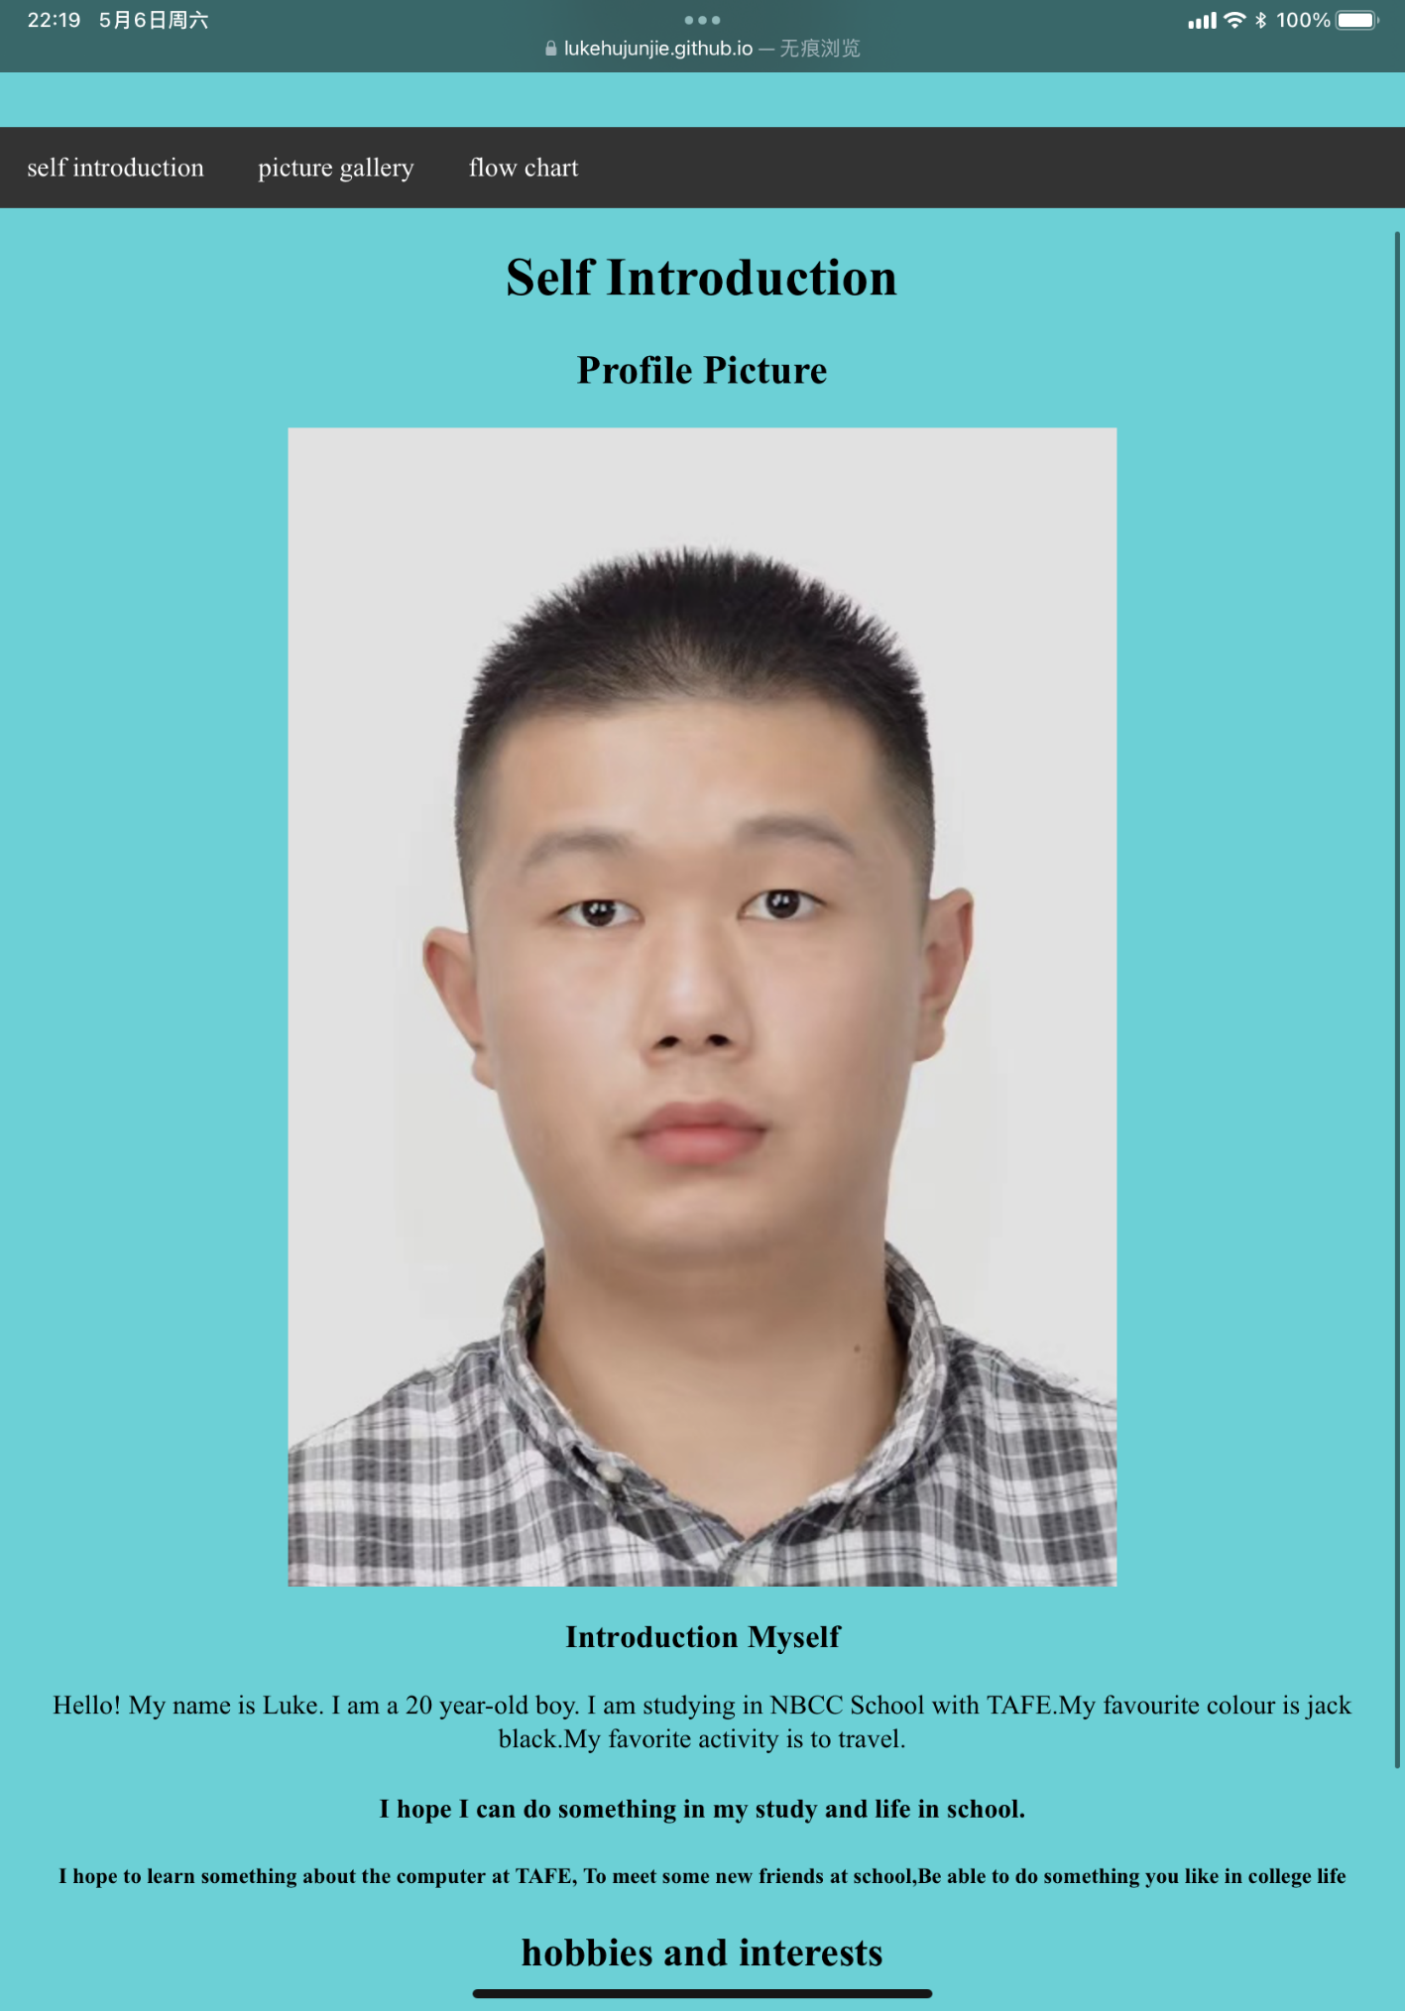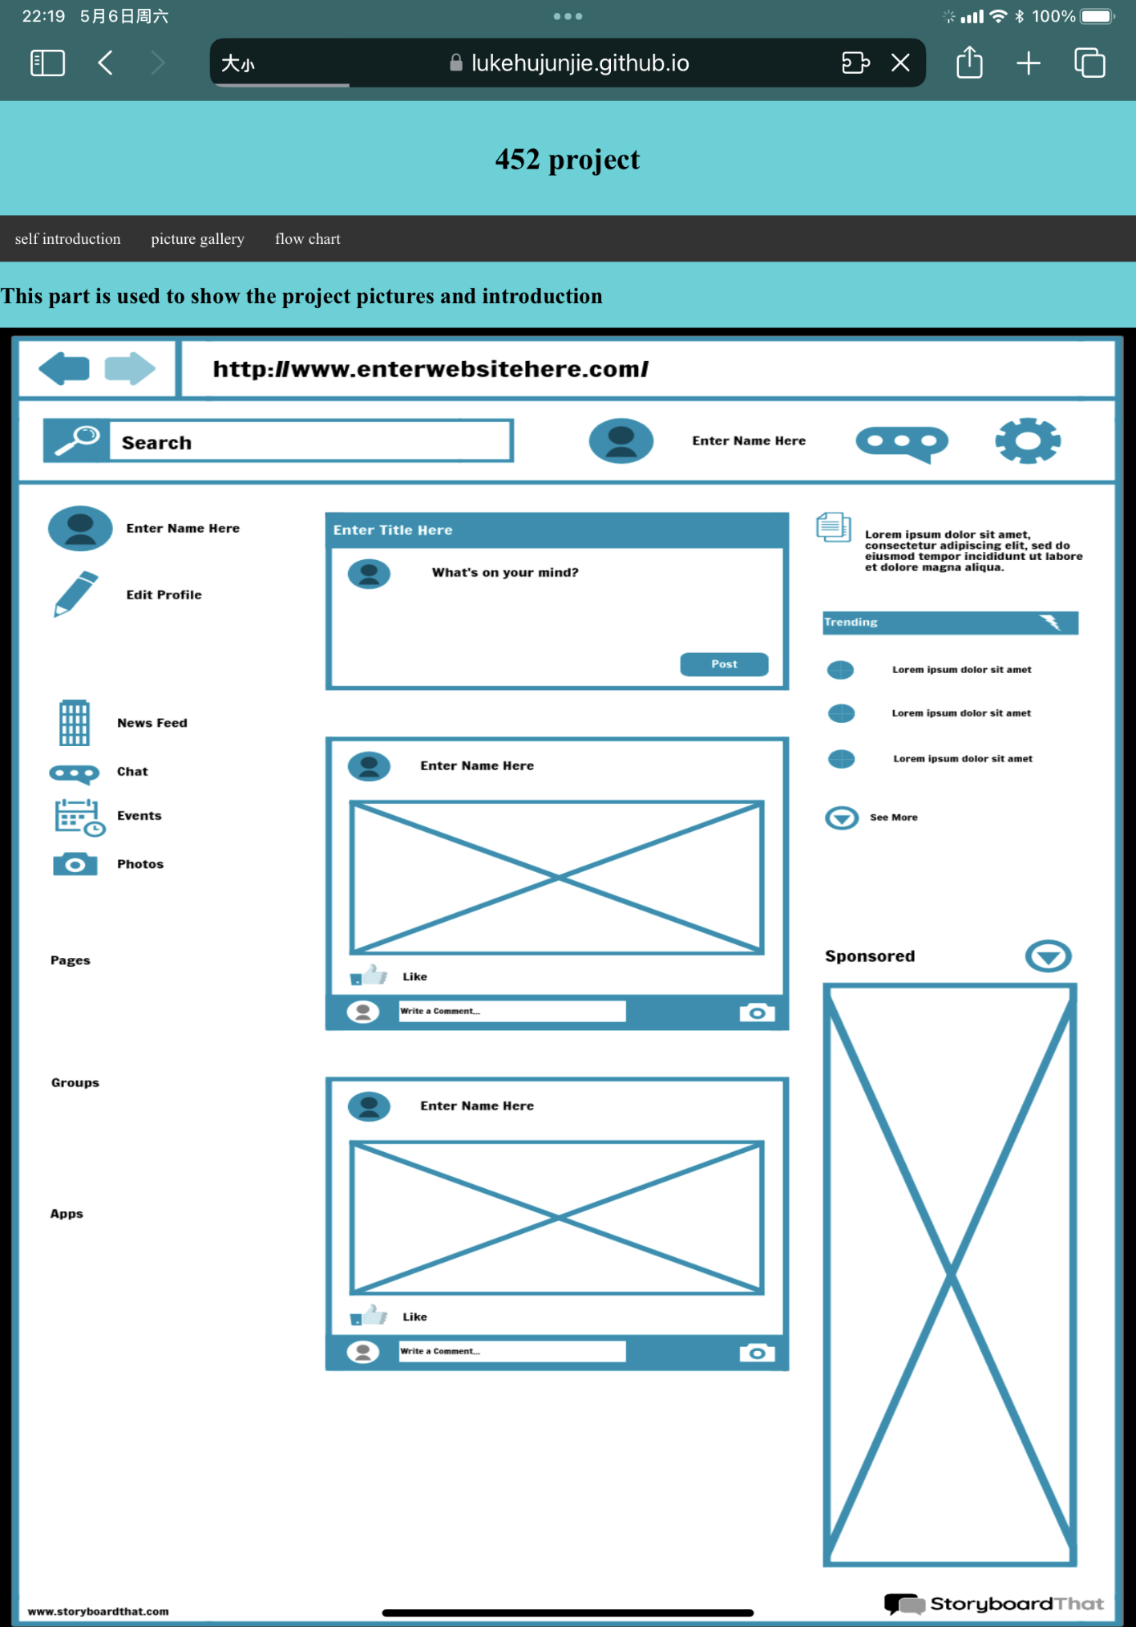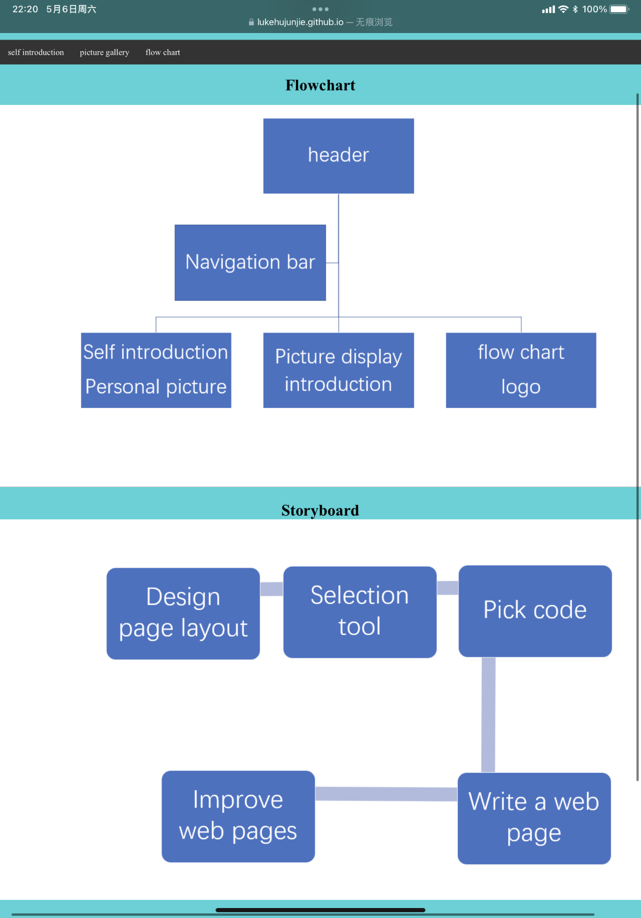

Appendix 3

Cell phone

